Included in kit:
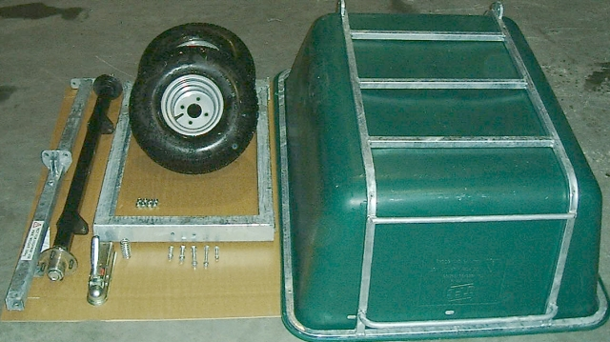
4

5
6

9

2
3
1
7

9) Nuts, bolts and spring, consisting of
M8 x 40mm Carriage bolt - 8 off
M10 x 40mm Hex bolt - 1 off
M10 x 65mm Hex bolt - 2 off
M12 x 25mm Hex bolt - 6 off.
M12 x 40mm Hex bolt - 2 off.
M12 x 75mm Hex bolt - 2 off.
M8 Nylock nuts – 8 off
M10 Nylock nuts - 3 off.
M12 Nylock nuts - 10 off.
Compression Spring (2³/₄” x 1³/₁₆” x 0.12”)
- Plastic Pan
- Pan frame
- Chassis
- Axle
- Drawbar
- Wheels
- Hitch
- Foot latch (Not shown)

Tools required:
2 x 17mm wrenches.
2 x 19mm wrenches.
Wheel Brace or

Assembly:
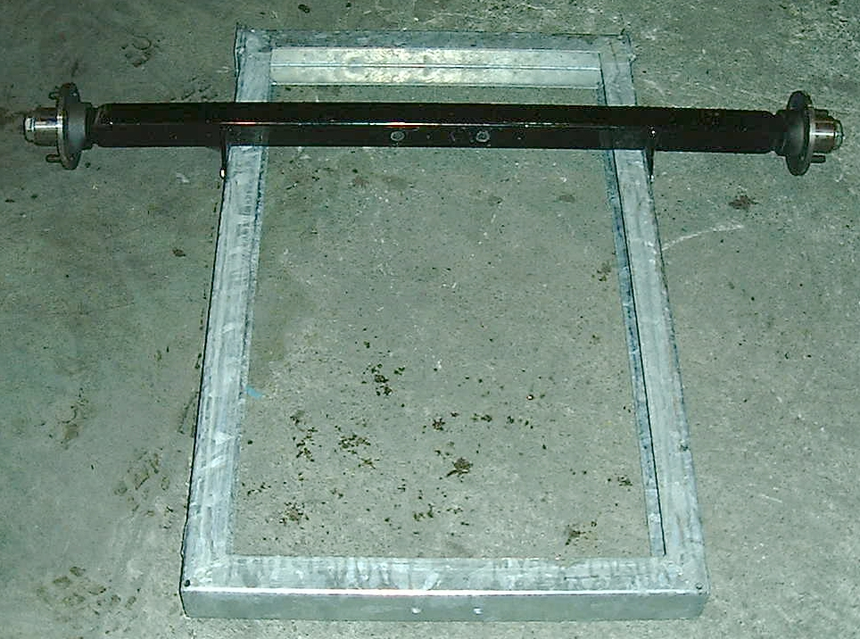
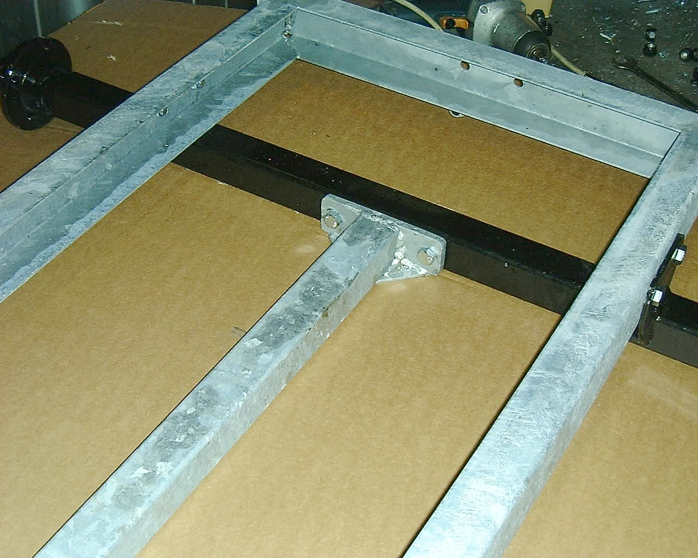

Attach axle to chassis using 4 - M12 x 25mm bolts and nuts ensuring that hinge lugs are facing in opposite direction.
Attach drawbar to axle using 2 - M12 x 75mm bolts and nuts. Attach the drawbar to the chassis using 2 – M12 x 25mm bolts and nuts.
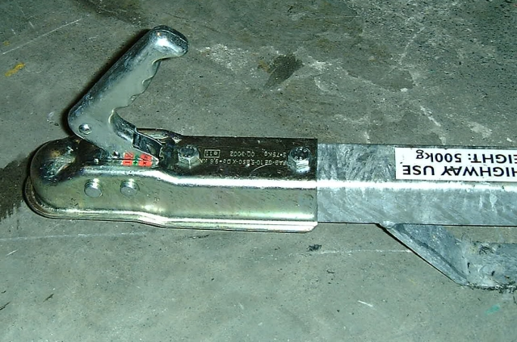
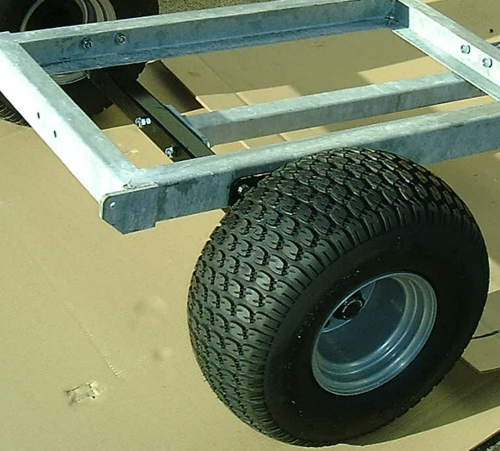
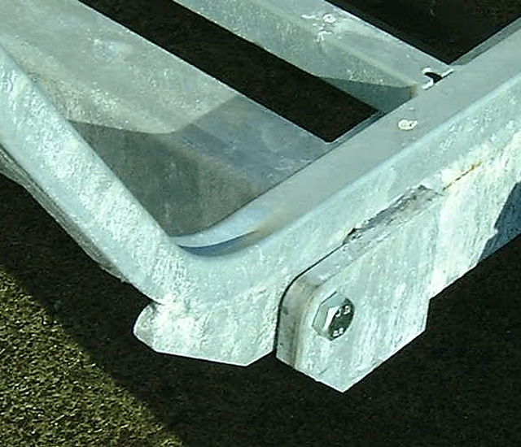
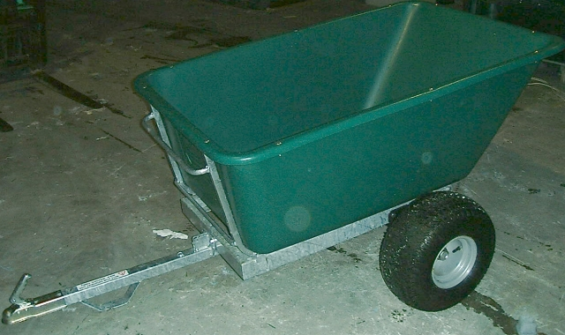
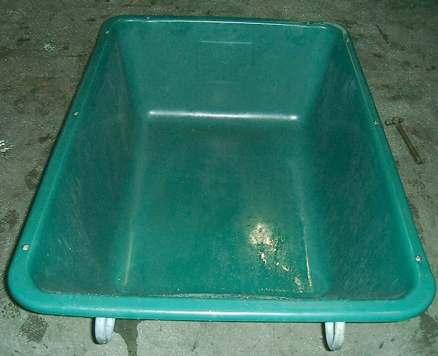
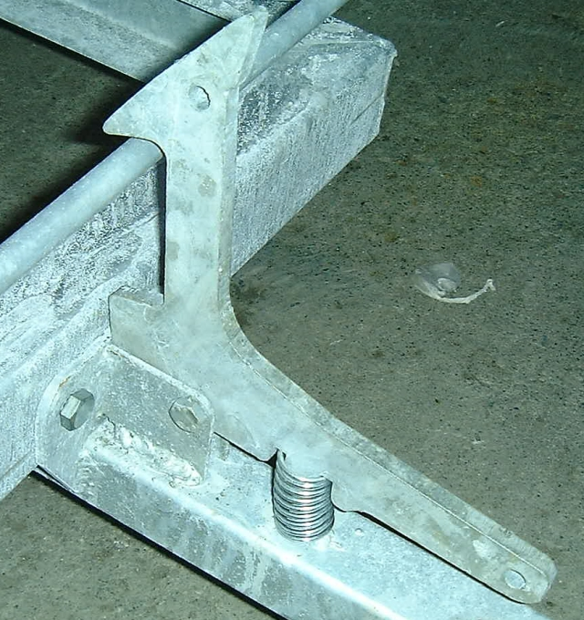
Attach Wheel to Chassis using the nuts attached to the hubs. Tighten nuts with a wheel brace, ensuring that nuts are tight.
Attach hitch to chassis using 2 - M10 x 65mm bolts and nuts.
Attach food pedal to the drawbar using M10 x 40mm Hex bolt and nut. Place compression spring between hitch and plug on the drawbar. Tighten to remove play in components.
Attach hitch to chassis using 2 - M10 x 65mm bolts and nuts.
Place pan into pan frame. Attach using M8 x 40 mm carriage bolts and nuts.
Finished unit

